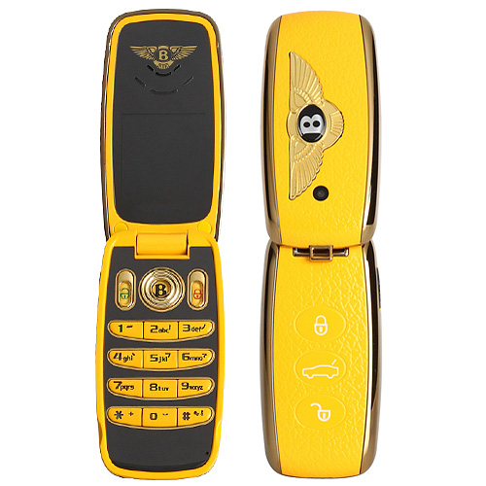
1 and 2
One SIM One Standby
Bands: GSM900/1800MHz
Languages: English and other languages
LCD: 1.4 inch QCF color screen
TV: No
FM radio: No

MP3: Yes
MP4: Yes,

Bluetooth: Yes
Memory: Support T-flash slot
Camera: 1.3Mega
Battery: 500mAh.
Standby time: 60hours
Standard Accessories:

two batterys, one charger, one earphone, one date cable, one keychain

Colors: Black, White, Red,Blue, Orange

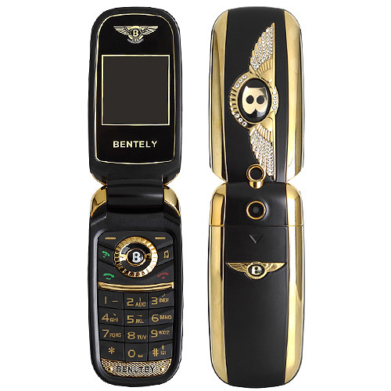

5
Frequency GSM900/1800MHz/850/1900MHz
Platform MTK52D
Color black,red,gray,sliver
Type Dual SIM Dual Standby
Bluetooth Yes
FM Yes
Camera 0.3MP
Display 1.44inch
Memory support T-flash card
Weight About 95g
Battery 380mah
Standby time About 5days
Main function MP3/MP4, FM, Bluetooth, Camera, LED Flashlight, T-flash Card
Additional calculator,to-do list,world time,alarm etc.
Accessories 1*battery,1*charger,1*manual book,1*USB cable,1*earphone
Language:Multi
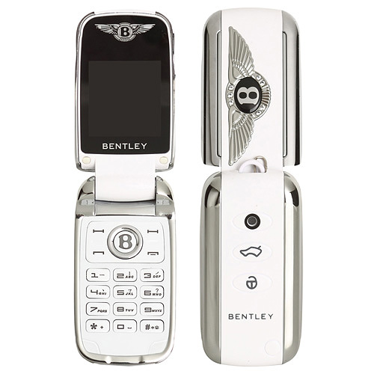

3 and 4
frequency:Dual band 900/1800MHz

network GSM

screen:1.2 inch OLED color screen( 240×320 )
Platform:MTK MT6252A
Audio:mp3/4,FM
Memory:64M+0
T-Flash Card:support, Max 4G
Color:black/white/red/Blue
Language:Chinese, English, French, German, Turkish, more text, Bahasa Indonesia,

Russian, Thai, Portuguese, Spanish, Persian, Arabic
Bluetooth:Support

camera:Yes
SMS/MMS:support SMS
SIM cards:Dual sim card
otherfunciton:Bluetooth,MP3,hand-free, T-Flash card, Calender,calculator, Alarm
Accessories:earphone*1,battery*2,USB cable*1,key chain*1,charger*1

